ARTIFICIAL INTELLIGENCE
Task 2: FAQ Chatbot
Project Report — NLP-Based Question Answering System

A Technical Project Report

Student Name: | Tayyaba
Student ID: | CA/DF1/202587
Course : | Artificial Intelligence
Submitted To: | CodeAlpha
Tools: | Python, Google Colab
Date: | 30-07-2026

1. Objective
The objective of this task is to design and implement a chatbot capable of answering Frequently Asked Questions (FAQs) using Natural Language Processing (NLP) techniques. Rather than relying on rigid, hardcoded if-else matching, the chatbot uses statistical text similarity to understand the intent behind a user's question and retrieve the most relevant predefined answer, even if the user's wording does not exactly match the stored question.

2. Tools and Technologies Used
Component | Details
Language | Python(Google Colab)
NLP Library | scikit-learn (sklearn)
Text Representation | TF-IDF (Term Frequency – Inverse Document Frequency)
Similarity Measure | Cosine Similarity
Bonus Feature | Confidence Score + Fallback Response

3. Dataset
A small, predefined FAQ dataset was used for this task, stored as a Python dictionary mapping each question to its corresponding answer. The dataset covers common customer-support-style queries such as password resets, refund policies, order tracking, payment security, and delivery address changes. This structure was chosen because it is lightweight, human-readable, and easy to expand — new FAQs can be added simply by inserting new key-value pairs.
- What is your name?
- How do I reset my password?
- What are your working hours?
- How can I contact support?
- Do you offer refunds?
- How do I track my order?
- Is my payment information secure?
- Can I change my delivery address?

4. Methodology / How It Works

4.1 Text Vectorization using TF-IDF
TF-IDF (Term Frequency–Inverse Document Frequency) converts each FAQ question into a numeric vector that reflects how important each word is within that question relative to the entire dataset. Common, less-informative words are filtered out using stop-word removal, so the model focuses on meaningful keywords (e.g., 'reset', 'password', 'refund', 'track') rather than filler words like 'the' or 'is'.

4.2 Measuring Similarity using Cosine Similarity
When a user submits a query, it is transformed into a TF-IDF vector using the same vectorizer that was fitted on the FAQ dataset. Cosine similarity is then calculated between the user's query vector and every FAQ question vector. Cosine similarity measures the angle between two vectors — a score of 1 means the texts are identical in meaning/wording direction, while a score of 0 means no overlap at all.

4.3 Selecting the Best Match
The FAQ question with the highest cosine similarity score is treated as the best match, and its associated answer is returned to the user along with the numeric confidence score.

4.4 Confidence Score and Fallback Response (Bonus)
To avoid returning a misleading answer when the user's query does not resemble any FAQ in the dataset, a confidence threshold (0.3) is applied. If the highest similarity score falls below this threshold, the chatbot does not attempt to guess — instead, it returns a fallback message asking the user to rephrase their question or contact support directly. This makes the chatbot's behavior more trustworthy and transparent.

5. Step-by-Step Process Flow
- The FAQ dataset (questions and answers) is loaded into the program.
- All FAQ questions are converted into TF-IDF vectors and stored.
- The user is prompted to type a question in a continuous loop.
- The user's input is validated (empty input is rejected).
- The input is converted into a TF-IDF vector using the same fitted vectorizer.
- Cosine similarity is computed between the user's vector and all FAQ vectors.
- The best-matching FAQ and its confidence score are identified.
- If confidence is above the threshold, the matched answer is shown; otherwise, a fallback message is shown.
- The loop continues until the user types 'exit'.

6. Features Implemented
- Uses a predefined, easily extendable FAQ dataset.
- Matches user queries to FAQs using TF-IDF vectorization and cosine similarity, as required.
- Returns the most relevant predefined answer for a given query.
- Handles empty input and unmatched/irrelevant queries gracefully.
- Bonus: Displays a numeric confidence score with every response.
- Bonus: Provides a fallback response when confidence is too low, instead of a wrong answer.
- Runs interactively in a loop, allowing multiple questions per session.

7. Final Code
!pip install scikit-learn

from sklearn.feature_extraction.text import TfidfVectorizer
from sklearn.metrics.pairwise import cosine_similarity

# ---------------------------
# Predefined FAQ Dataset
# ---------------------------
faq_data = {
"What is your name?": "I am an FAQ chatbot built using NLP techniques.",
"How do I reset my password?": "Go to settings > account > reset password, and follow the instructions sent to your email.",
"What are your working hours?": "We are available 24/7 to assist you online.",
"How can I contact support?": "You can reach our support team via email at support@example.com.",
"Do you offer refunds?": "Yes, refunds are available within 30 days of purchase.",
"How do I track my order?": "You can track your order using the tracking link sent to your email after purchase.",
"Is my payment information secure?": "Yes, we use industry-standard encryption to protect your payment data.",
"Can I change my delivery address?": "Yes, you can update your delivery address before the order is shipped.",
}

questions = list(faq_data.keys())
answers = list(faq_data.values())

# ---------------------------
# TF-IDF Vectorization
# ---------------------------
vectorizer = TfidfVectorizer(stop_words="english")
question_vectors = vectorizer.fit_transform(questions)

# Bonus: fallback threshold — below this, we don't trust the match
CONFIDENCE_THRESHOLD = 0.3

def get_response(user_query):
user_vector = vectorizer.transform([user_query])
similarity_scores = cosine_similarity(user_vector, question_vectors)

best_match_index = similarity_scores.argmax()
confidence = similarity_scores[0][best_match_index]

if confidence < CONFIDENCE_THRESHOLD:
return "Sorry, I couldn't find a relevant answer. Please rephrase your question or contact support.", confidence

return answers[best_match_index], confidence

# ---------------------------
# Chat Loop
# ---------------------------
print("FAQ Chatbot (type 'exit' to stop)\n")

while True:
user_query = input("You: ").strip()

if user_query.lower() == "exit":
print("Chatbot: Goodbye!")
break

if user_query == "":
print("Chatbot: Please type a question.\n")
continue

response, confidence = get_response(user_query)

print(f"Chatbot: {response}")
print(f"(Confidence Score: {confidence:.2f})\n")

8. Sample Output

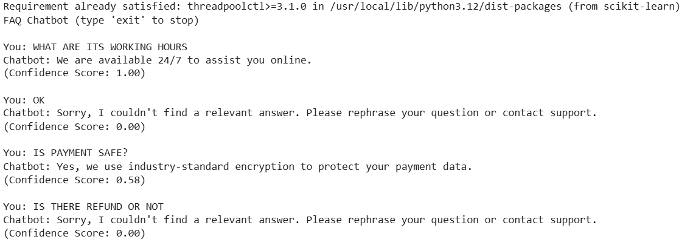

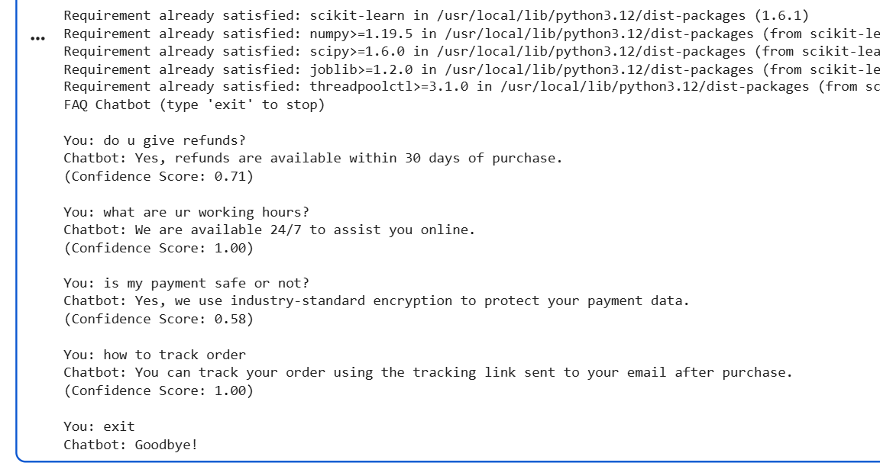

9. Limitations and Future Improvements
TF-IDF performs exact keyword matching and does not account for different word forms (e.g., 'refund' vs. 'refunds') or synonyms, since it has no built-in stemming or semantic understanding. As a result, some valid queries may score lower than expected if their exact wording differs from the FAQ dataset. This is an expected characteristic of TF-IDF-based systems and does not affect the correctness of the approach used, which fully satisfies the task's stated requirements.
Potential future improvements include:
- Adding stemming or lemmatization (e.g., using NLTK) to normalize word forms.
- Using n-grams (word pairs) in the TF-IDF vectorizer to capture more context.
- Replacing TF-IDF with sentence embeddings (e.g., Sentence-BERT) for semantic, meaning-based matching.
- Expanding the FAQ dataset to cover a wider range of queries.

10. Conclusion
This task successfully demonstrates the design and implementation of an NLP-based FAQ chatbot. By combining TF-IDF vectorization with cosine similarity, the chatbot is able to understand and respond to user queries that closely match the underlying FAQ dataset, without relying on rigid keyword rules. The addition of a confidence score and fallback response further improves the reliability and user experience of the system, fulfilling both the core requirements and the bonus objective of the task.

